纽锋充电器产品说明书
Newfon charging cabinet manual

目录

Table of contents

1.产品的外观说明Product appearance description

2.主要参数Main parameters

3.关键特性Key features

4.产品使用方法Product usage instructions

5.使用注意事项Usage precautions

6.产品维护Product maintenance

- 产品外观说明
Product appearance description

面板上依次为主电源开关及功能指示灯，多功能显示屏

On the panel, there are the main power switch, function indicator lights, and the multifunctional display screen.
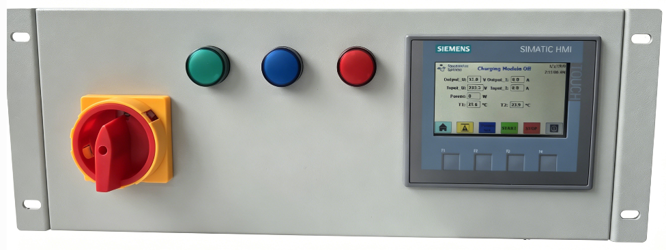
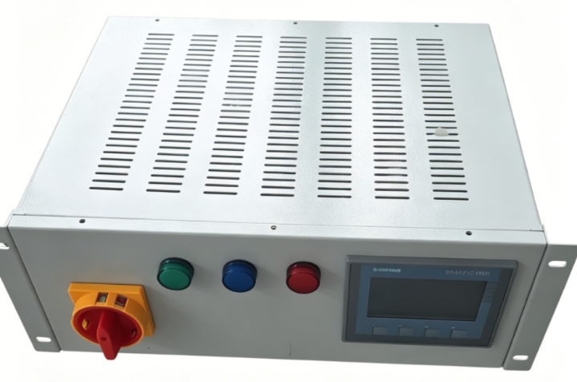

表 1：指示灯状态与异常原因
Table 1: Indicator light states and abnormal reasons
指示灯颜色
状态
状态说明
处理建议

Indicator Light Color | Status | Status Description | Suggestion
红色  Red | 常亮  Steady  on | 充电器故障  Charger fault | 联系售后人员处理  Contact after-sales personnel  for assistance
红色  Red | 关闭  Off | 充电器正常  Charger is normal
蓝色 | 常亮 | 电池接入 | 电池接入后指示灯亮起

Blue | Steady  on | Battery connected | Indicator illuminates after battery connection.
Blue | 关闭  Off | 电池没有接入  Battery not connected
绿色  Green | 常亮  Steady  on | 充电器运行  Charger ON
绿色  Green | 关闭  Off | 充电器关闭  Charger OFF

多功能显示屏. Multifunctional display screen

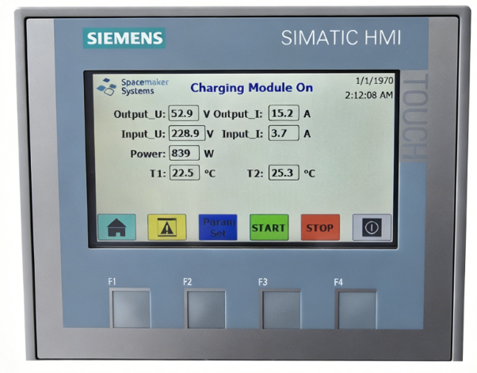
1.“Charging Module On”充电运行状体显示。
“Charging Module On” Charger running status display。
2. “Charging Module Off” 停止充电显示。
“Charging Module Off” Charging stop status display。
3.“Output_U”输出电压显示。
“Output_U” Output voltage display。
4.“Output_A”输出电流显示。
“Output_A” Output current display。
5.“Input_U”输入电压显示。
“Input_U” Input voltage display。
6. “Input_I”输入电流显示。
“Input_I” Input current display。
7.“Power”输入功率显示。
“Power” Input power display。
8.“T1”,“T2”充电器内部温度显示。
“T1”,“T2” Internal charger temperature display。
9.“”回到主界面显示按钮。Return to Main Screen Button。
10. “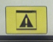”故障显示界面按钮。Fault Display Button。
11. “ 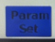”参数设置界面按钮，设置充电电压和充电电流值。Parameter Setting Interface Button，Set charging voltage and charging current values。
12. “”手动启动充电按钮。Manual Start Charging Button。
13. “”手动停止充电按钮。Manual Stop Charging Button。
14. “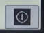”触摸屏关机按钮。Touch Screen Shutdown Button。

- 主要参数

Main parameters

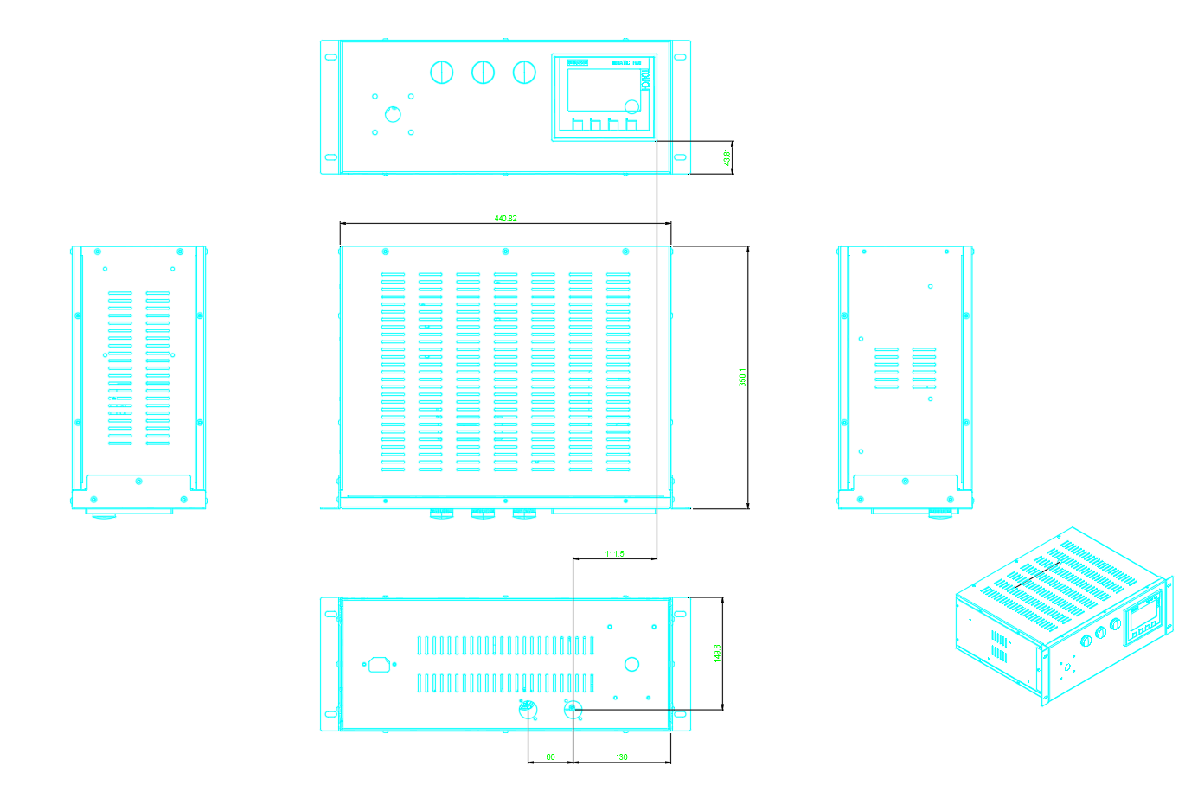

效率 | 峰值效率:97.0%;  ≥96% (110-240V AC，30%~80%负载)
高×宽×深 | 440mm×410mm×190mm
重量 | >=13kg
冷却方式 | 内置风扇(具有温控调速功能)
本充电器额定输出限定为 1.8Kw

Efficiency | Peak efficiency: 97.0%;  ≥96% (110-240V AC, 30%~80% load)
Height × Width × Depth | 440mm×410mm×190mm
Weight | >=13kg
Cooling method | Built-in fan (with temperature control and  speed adjustment function)
The rated output of this charger is limited to 1.8 Kw

电气特性

项目 | 指标
输入特性
输入电压范围 | 110-240V AC +-5%
输入频率 | 50Hz~60Hz;  额定值为50Hz/60Hz
额定输入电流 | ≤8.5A
功率因数 | ≥0.97(50%~100%负载)
THD | ≤5%(50%~100%负载)
输出特性
输出电压 | 42V DC~58V DC;  额定值为54V DC;
输出功率 | 1800W (230V AC )
峰值效率 | 97%±0.2%
稳压精度 | ≤±0.6%*Vo
纹波和噪声 | ≤200mVp-p(带宽≤20MHz)
动态响应 | - 25%~50%、50%~75%跳变:  −超调:≤±5%  −恢复时间:≤200μs (±0.6%*Vo)  - 10%~90%跳变:  −超调:≤±5%  −恢复时间:≤1ms (±1%*Vo)
待机功耗 | ≤5W
开机启动时间 | 3s~10s
输出保持时间 | >10ms
杂音电压 | ≤2mV
宽频杂音电压 | ≤50mV (3.4kHz~150kHz)  ≤20mV (0.15MHz~30MHz)

Electrical characteristics

Item | Indicator
Input characteristics
Input voltage range | AC~110-240V +-5%
Input frequency | 50Hz~60Hz  rated at 50Hz/60Hz
Rated input current | ≤8.5A
Power factor | ≥0.97 (50%~100% load)
THD | ≤5% (50%~100% load)
Output characteristics
42V DC~58V DC;
rated at 54V DC;
Output power | MAX1800W (230V AC)
Peak efficiency | 97%±0.2%
Voltage stabilization accuracy | ≤±0.6%*Vo
Ripple and noise | ≤200mVp-p (bandwidth≤20MHz)
Dynamic response | Transition from 25% to 50%, and from 50% to 75%: - Overshoot: ≤±5%  - Recovery Time: ≤200μs (±0.6%*Vo) Transition from 10% to 90%: - Overshoot: ≤±5% - Recovery Time:  ≤1ms (±1%*Vo)
Standby power consumption | ≤5W
Boot time | 3s~10s
Output retention time | >10ms
Noise voltage | ≤2mV
Wideband noise voltage | ≤50mV (3.4kHz~150kHz) ≤20mV  (0.15MHz~30MHz)

- 关键特征

Key features
- 宽输入电压范围
- 宽工作温度范围
- 低总谐波失真 (THD)
- 全数字化控制
- 支持智能电表
- 支持LED显示告警
- 支持调压、调流功能
- 支持320V AC离线功能
- 通过CE认证
- 支持热插拔功能

- Wide input voltage range
- Wide operating temperature range
- Low total harmonic distortion (THD)
- Fully digital control
- Support smart meters
- Support LED display alarm
- Supports voltage regulation and current regulation functions
- Offline functionality with support for 320V AC
- Obtained CE certification
- Support hot-swappable function

其他特性

项目 | 指标
保护特性
输入过压保护 | 交流保护点:>300V AC
输入过压保护 | 交流恢复范围:290V AC~300V AC
输入欠压保护 | 交流保护点:<80V AC
输入欠压保护 | 交流恢复点:80V AC~90V AC
输出过压保护 | 范围为 56V DC~60V DC;  - 内部故障过压时，模块锁死。  - 外部电压大于 63V DC，且持续 500ms 左 右，模块锁死。
输出限流保护 | 见图 1
输出短路保护 | 可长期短路，短路消失后可自动恢复。
过温保护 | 具有过温保护功能。
EMC/防雷特性
认证 | CE 认证
EMC | EN 55032，EN 55024，EN 61000-3-2， EN 61000-3-3;ETSI EN 300 386，  ETSI EN201 468;ETSI EN 301489; ITU-T K.20
防雷 | 5kA(8/20μS)
可靠性特性
MTBF | ≥50 万小时 (40°C)
音响噪声
指标 | ≤55dB(A) (40°C)

Item | Indicator
Protection characteristics
Input overvoltage protection | AC protection point: >300V AC
Input overvoltage protection | AC recovery range: 290V AC~300V AC
Input undervoltage protection | AC protection point: <80V AC
Input undervoltage protection | AC recovery point: 80V AC~90V AC
Output overvoltage protection | Range: 56V DC~60V DC;  - Module lockout in case of internal fault overvoltage.  - Module lockout if external voltage exceeds 63V  DC and lasts for approximately 500ms.
Output current limit protection | See figure 1
Output short circuit protection | Can withstand long-term short circuits; automatic recovery after the short circuit  disappears.
Overtemperature protection | Equipped with overtemperature protection  function.
EMC/Lightning protection characteristics
Certification | CE certified
EMC | EN 55032, EN 55024, EN 61000-3-2,  EN 61000-3-3; ETSI EN 300 386,  ETSI EN201 468; ETSI EN 301489; ITU-T K.20
Lightning protection | 5kA(8/20μS)
Reliability characteristics
MTBF | ≥500,000 hours (40°C)
Acoustic noise
Specifications | ≤55dB(A) (40°C)

输出特性

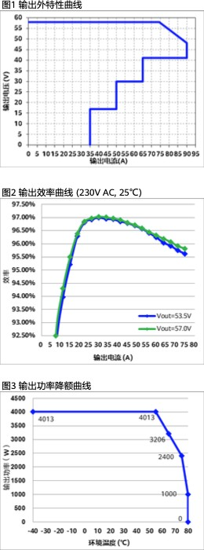

输出特性
Output characteristics

图 1 输出外特性曲线
Figure 1: Output external characteristic curve

输出电压（V）
Output voltage (V)

输出电流（A）
Output current (A)

图 2 输出效率曲线 (230V AC, 25°C)
Figure 2: Output efficiency curve (230V AC,
25°C)

效率
Efficiency

输出电流（A）
Output current (A)

图 3 输出功率降额曲线
Figure 3: Output power derating curve

输出功率（W）
Output power (W)

环境温度（°C ）
Ambient temperature (°C)

- 产品使用方法

Product usage instructions
- 给充电器接入电源。Connect power supply to the charger.
- 把电池接入X2的48V和0V端子上。Connect the battery to terminals 48V and 0V on connector X2.
- 在RJ45接口处接入网线，与西门子PLC进行PN通信，由西门子PLC控制充电器工作，以及修改充电器充电电压和充电电流参数，监控充电状态。Connect an Ethernet cable to the RJ45 interface for PROFINET (PN) communication with the Siemens PLC.The PLC controls charger operation, sets charging voltage and current, and monitors charging status.
- 在端子X3处接入外部传感器，或者给端子I0.0一个24V电压信号，开始充电；断开24V电压信号停止充电。Connect an external sensor to terminal X3, or apply a 24V voltage signal to terminal I0.0 to initiate charging. Disconnect the 24V voltage signal to stop charging.
- 在触摸屏上点击“START”按钮开始充电，点击“STOP”按钮停止充电。Press the "START" button on the touch panel to start charging; press the "STOP" button to stop charging.

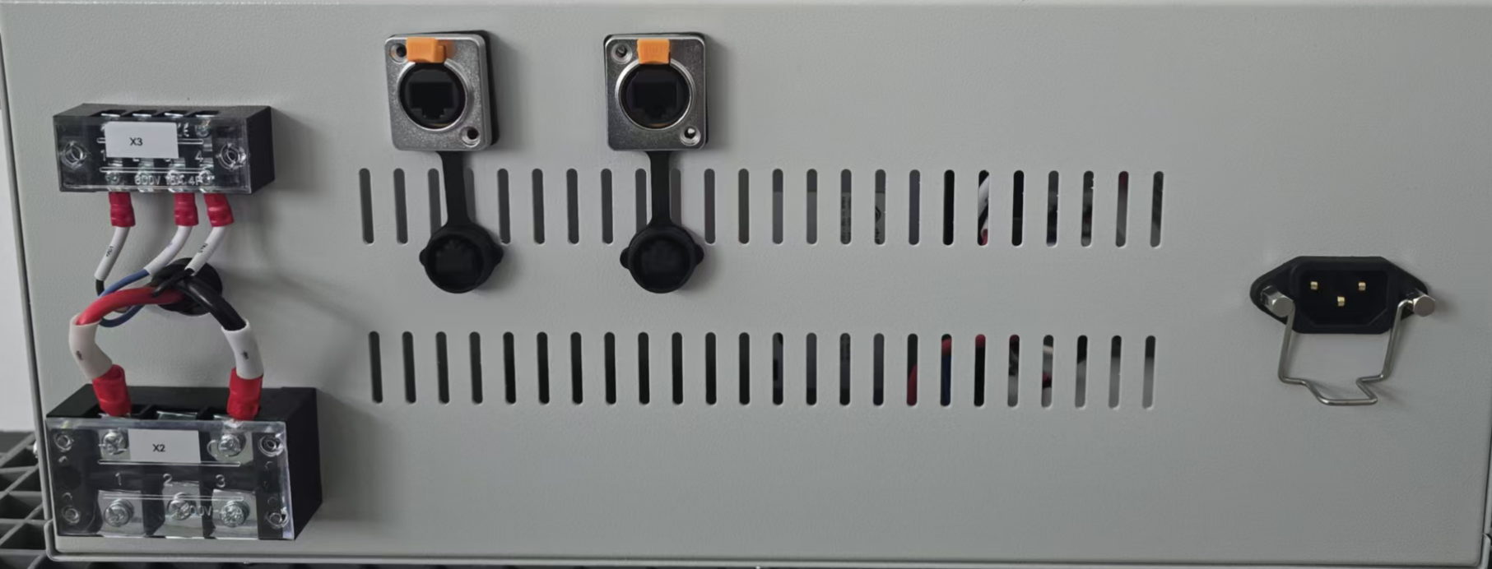

- 使用注意事项

Usage precautions
运输
Transportation
产品运输时应有牢固的包装箱。箱外面应符合相关国标的规定且应有“小心轻放”、“防潮”等标志。装有产品的包装箱允许用任何运输工具运输。运输中应避免雨、雪的直接淋袭和机械撞击。
The product should be transported in securely packed boxes. The exterior of the boxes should comply with relevant national standards and display signs such as "Handle with Care" and "Moisture-Resistant." The packaging boxes containing the product are allowed to be transported by any means of transportation. During transportation, direct exposure to rain, snow, and mechanical impacts should be avoided.

储存
Storage

产品未使用时应存放在包装箱内， 在–40℃~+75℃和相对湿度不大于 80%的干燥、通风、无腐蚀性气体影响的库房内。
When the product is not in use, it should be stored in its packaging box in a dry, well-ventilated warehouse with a temperature range of -40°C to +75°C and a relative humidity not exceeding 80%. The storage area should be free from corrosive gases.

使用环境
项目 | 指标
工作温度范围 | 0°C~+50°C
存储温度范围 | –20°C~+60°C
相对湿度 | 5%RH~95%RH(无凝露)
海拔高度 | ≤5000m (2000m~5000m，海拔每升高 200m，温度降低 1°C。)

Operating environment
Item | Indicator
Operating temperature range | 0°C~+50°C
Storage temperature range | –20°C~+60°C
Relative humidity | 5%RH~95%RH (non-condensing)
Altitude | ≤5000m (2000m~5000m, the temperature decreases by 1ºC for  every 200m increase in altitude)

注意！
Caution!
- 充电器的安装和维护人员必须经过专业的培训。
- 充电器模块不适用于双火线供电场景。
- 本产品应在符合用户手册规格要求的环境下使用。
- 在电网输入异常情况下使用产品或直接将产品暴露在盐雾、粉尘、水雾等环境下，易导致产品出现故障，由此引发的功能异常或部件损坏不在质量保证范围之内。

- Installation and maintenance personnel of the charger must undergo professional training.
- There is a 15A fuse on the L line of the charger's input end (the module is not suitable for scenarios with dual live-wire power supply).
- T The charger module is not intended for two-line (L-L) power supply scenarios..
- Using the product during abnormal conditions in the power grid or exposing it directly to environments such as salt spray, dust, water mist, etc., may lead to malfunctions. Any resulting functional abnormalities or component damage are not covered by the quality guarantee.
注意！
Caution!
- 充电机柜拆包装后，建议7天内上电，如果
无法及时上电，则需要将充电机柜放置到室内、干燥、无腐蚀性气体的环境中。
- After unpacking the charger cabinet, it is recommended to power it on within 7 days. If unable to power it on promptly, the charger cabinet should be placed in an indoor, dry, and non-corrosive gas environment.

危险！
Danger!
- 高压电源为设备的运行提供电力，直接接触或通过潮湿物体间接接触高压电源，会带来致命危险。
- 不规范、不正确的高压操作，会引起火灾或电击等意外事故。
- The high-voltage power supply provides electricity for the operation of the equipment. Direct contact or indirect contact through wet objects with the high-voltage power supply can pose a deadly risk.
- Non-standard or incorrect high-voltage operations can lead to accidents such as fires or electric shocks.

- 产品维护

Product maintenance
充电柜需安装在干燥通风的环境下使用，如需保养请安排专业电工操作。内部安装有输出保险丝 40A；
出现断电等异常后，关闭前面板的总开关后方可打开充电柜查找故障；
The charging cabinet should be installed and used in a dry and well-ventilated environment. If maintenance is required, please arrange for a professional electrician to perform the operation.
Internally, there is a 40A output fuse
In case of power failure or other abnormalities, the charging cabinet can only be opened for troubleshooting after turning off the main switch on the front panel.

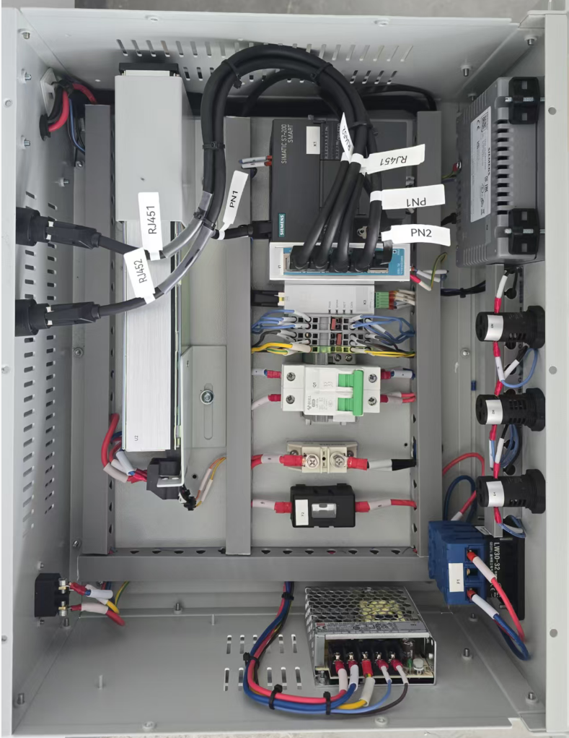
过流保护开关
Overcurrent protection switch

输出保险丝Output fuse

